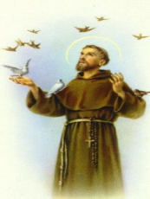

St. Francis of Assisi






Come & Talk to us!


(An Order of ordinary people, married & single, male & female, young & old)
Following Jesus in the spirit of St. Francis and St. Clare of Assisi

Come to an information session on date at Place
Location and time. For more information call:
??????

St. Francis of Assisi






Come & Talk to us!


(An Order of ordinary people, married & single, male & female, young & old)
Following Jesus in the spirit of St. Francis and St. Clare of Assisi

Come to an information session on date at Place
Location and time. For more information call:
??????

