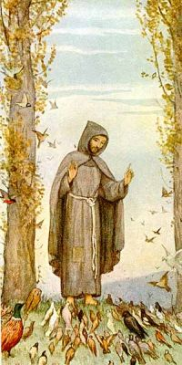
Prayer of St. Francis
Lord, make me an instrument of
your peace.
where there is hatred, let me
sow love.
where there is injury, pardon;
where there is doubt, faith;
where there is despair, hope;
where there is darkness, light;
where there is sadness, joy.
O Divine Master,
grant that I may not so much seek
to be consoled, as to console;
to be understood, as to understand;
to be loved, as to love.
For it is in giving that we receive;
it is in pardoning that we are
pardoned,
and it is in dying that we are born
to Eternal Life.
Prayer of St. Francis
Lord, make me an instrument of
your peace.
where there is hatred, let me
sow love.
where there is injury, pardon;
where there is doubt, faith;
where there is despair, hope;
where there is darkness, light;
where there is sadness, joy.
O Divine Master,
grant that I may not so much seek
to be consoled, as to console;
to be understood, as to understand;
to be loved, as to love.
For it is in giving that we receive;
it is in pardoning that we are
pardoned,
and it is in dying that we are born
to Eternal Life.
Prayer of St. Francis
Lord, make me an instrument of
your peace.
where there is hatred, let me
sow love.
where there is injury, pardon;
where there is doubt, faith;
where there is despair, hope;
where there is darkness, light;
where there is sadness, joy.
O Divine Master,
grant that I may not so much seek
to be consoled, as to console;
to be understood, as to understand;
to be loved, as to love.
For it is in giving that we receive;
it is in pardoning that we are
pardoned,
and it is in dying that we are born
to Eternal Life.
Prayer of St. Francis
Lord, make me an instrument of
your peace.
where there is hatred, let me
sow love.
where there is injury, pardon;
where there is doubt, faith;
where there is despair, hope;
where there is darkness, light;
where there is sadness, joy.
O Divine Master,
grant that I may not so much seek
to be consoled, as to console;
to be understood, as to understand;
to be loved, as to love.
For it is in giving that we receive;
it is in pardoning that we are
pardoned,
and it is in dying that we are born
to Eternal Life.

